21. Write a Pandas program to swap the cases of a specified character column in a given DataFrame.

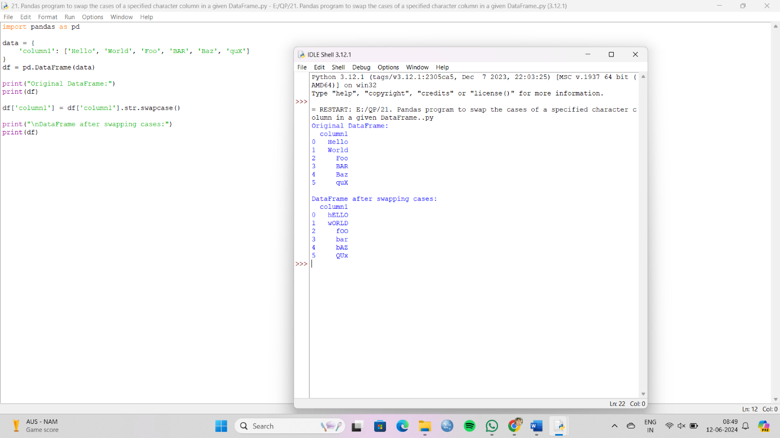

22. Write a Python program to draw a line with suitable label in the x axis, y axis and a title.  
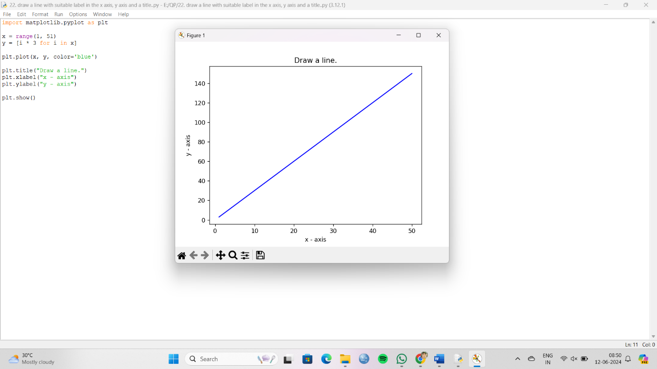

23. Write a Python program to draw a line using given axis values taken from a text file, with suitable label in the x axis, y axis and a title.  
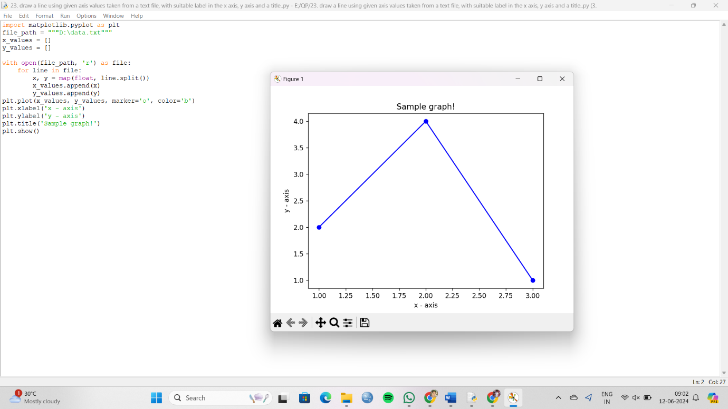

24. Write a Python program to draw line charts of the financial data of Alphabet Inc.

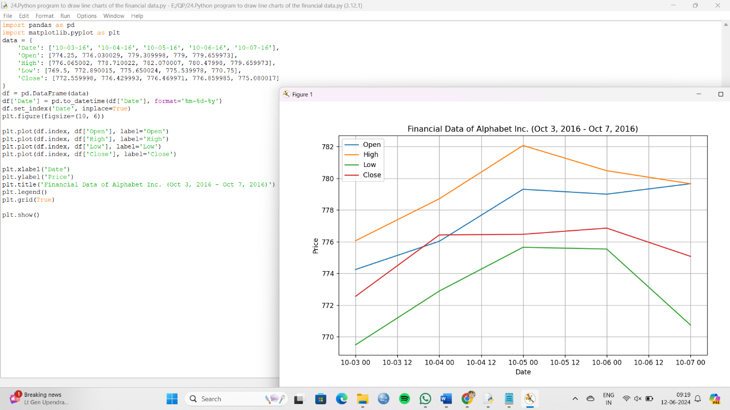

25. Write a Python program to plot two or more lines with legends, different widths and colors.

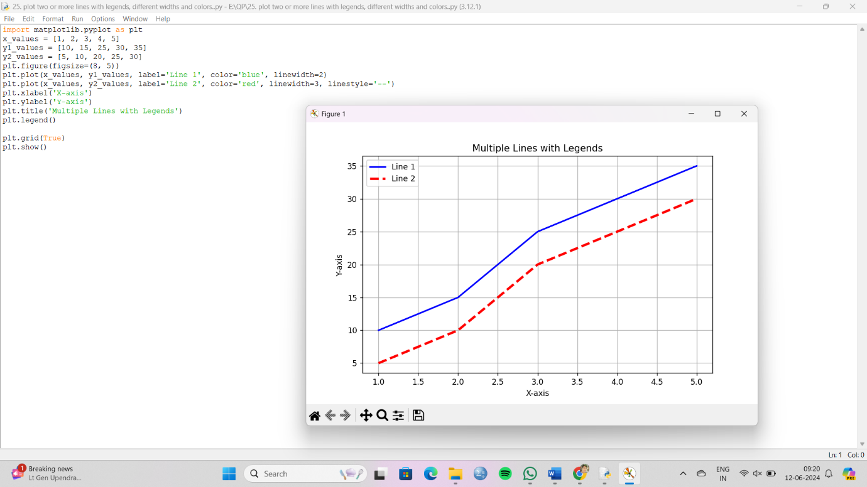

26. Write a Python program to create multiple plots.

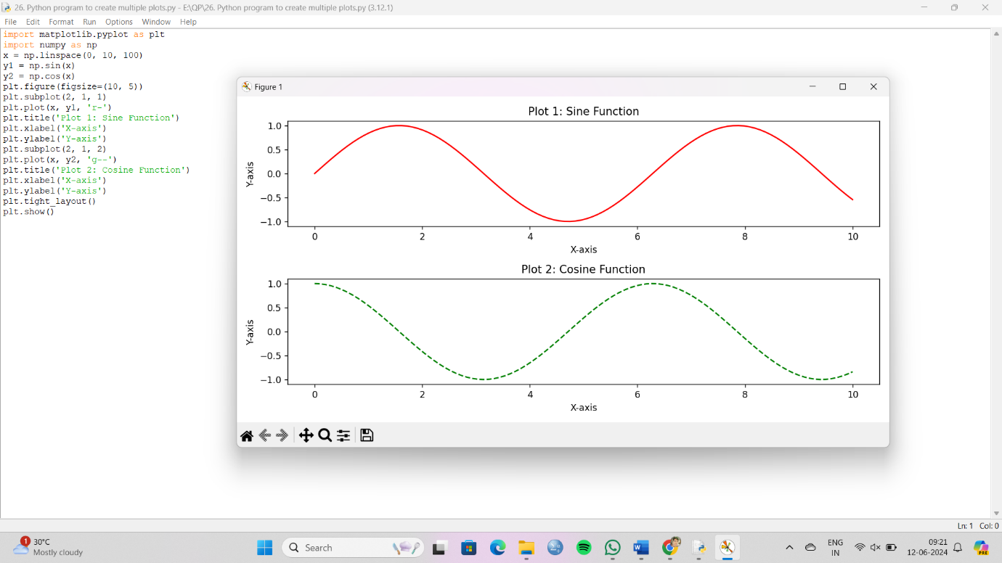

27. Write a Python programming to display a bar chart of the popularity of programming Languages.  
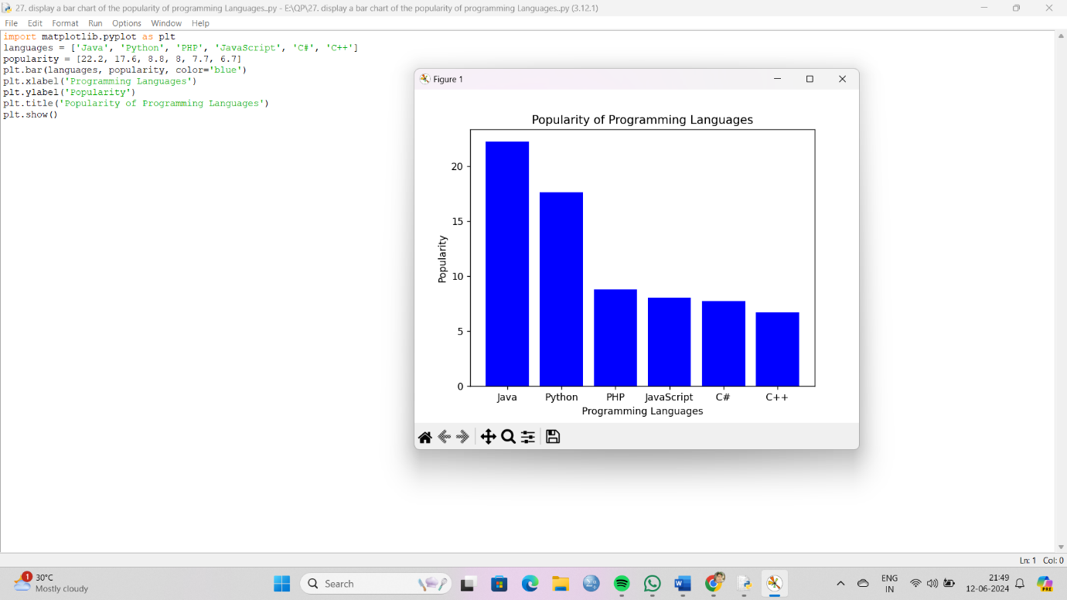

28. Write a Python programming to display a horizontal bar chart of the popularity of programming Languages.  
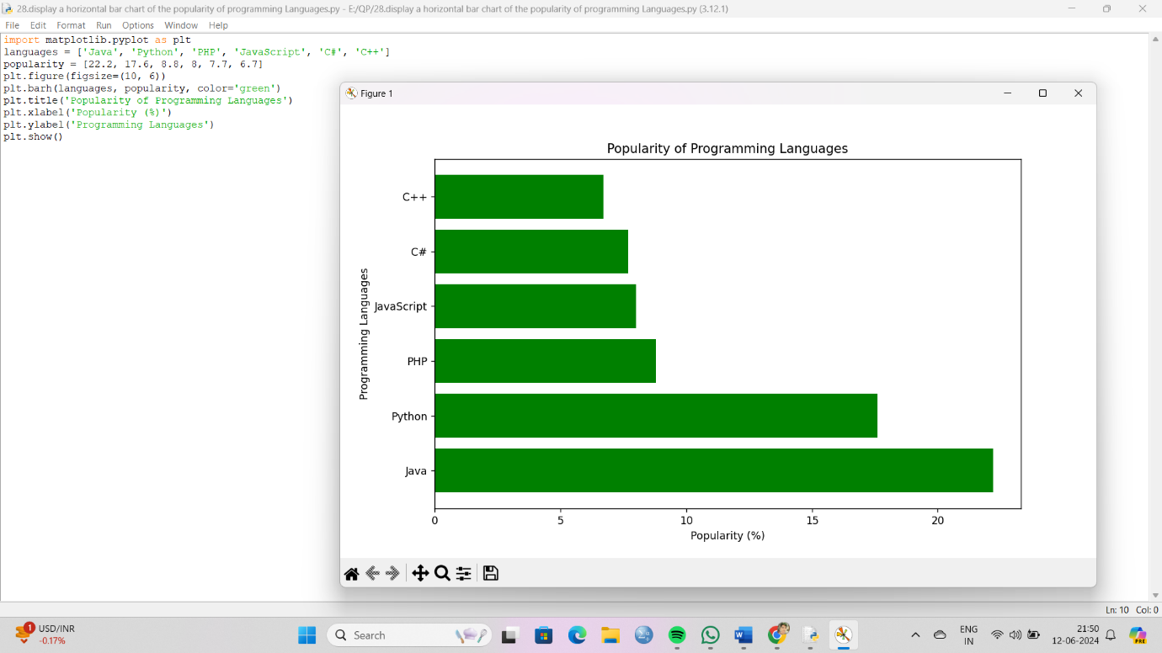

29. Write a Python programming to display a bar chart of the popularity of programming Languages. Use different color for each bar.  
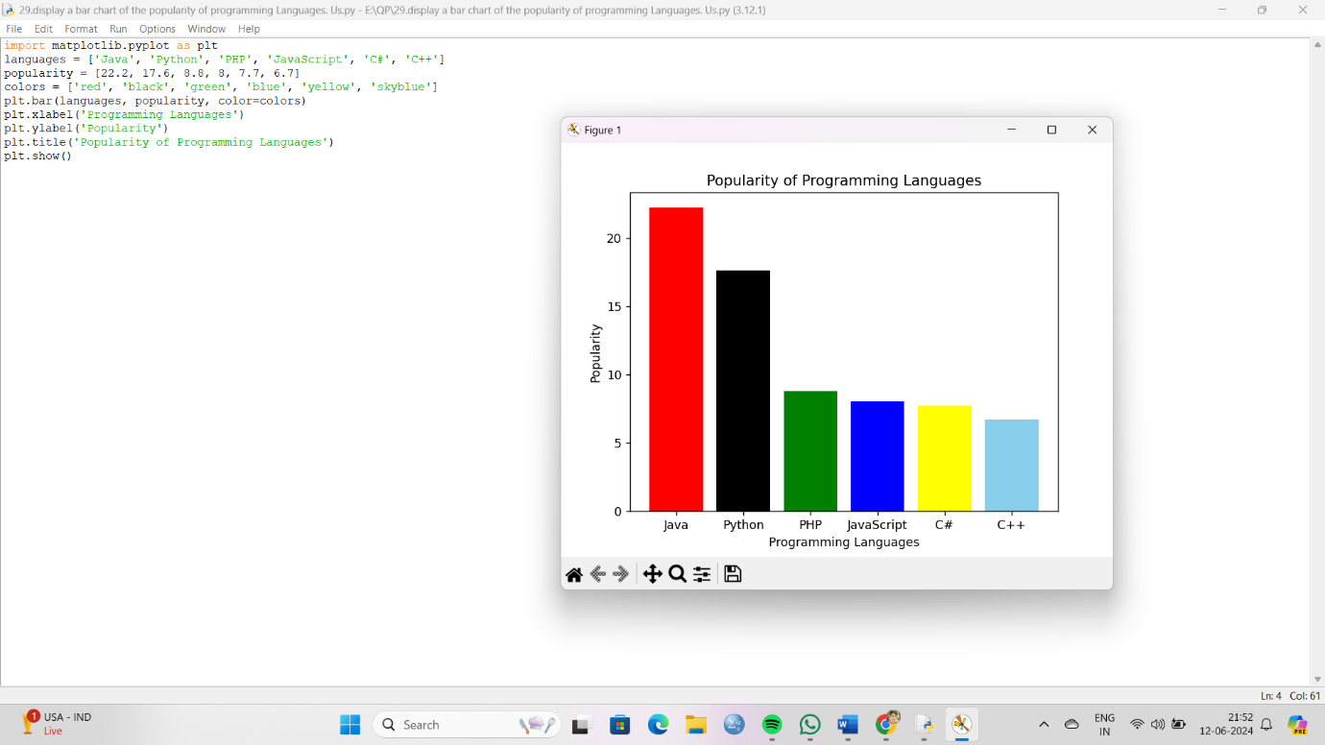

30. Write a Python program to create bar plot of scores by group and gender. Use multiple X values on the same chart for men and women.  
